Training Guide for Sales and Customer Support

## Background:

background : health care, helping KP’s patient

Problem : Type 2 disabetes, it can only be cured by exercise and good diet

-what Patient need is remote support

-forming good habit is not a one time effort

-there are various reasons for being unhealthy

Solution : solve causes of being unhealthy such as unhealthy environment to healthy

-Motivation is key feature

-provide reason to transform from bad to good habits

-understand own body condition

-step by step process to become physically active

How : with mobile application

-below are steps for using app

1.test the body condition

2.base on the body condition, app gives appropriate mission to become active

3.when patients accompolish the mission, they get points

4.some patients can get stars when they constantly finishing mission well

5.with points and star, patient can get discount

## Market background:

Target Audience : unhealth routine, bad habits, pain from type 2 diabetes

-possible audience :170m(included overweight) US people

-age from 18 ~ 45

-low income family

-unactive or indoor people

Ideal audience : target audience + below features

-having potential to transform

-local friend to buzz

-KP’s patient

-people who like our vision

What audience look like : patient who has unhealthy habits, inactive, unmotivated

-indoor preference

-app user

-might be self dissatisfaction

Target market : fitness appstore_TAM 22.4b

-app store_fitness category

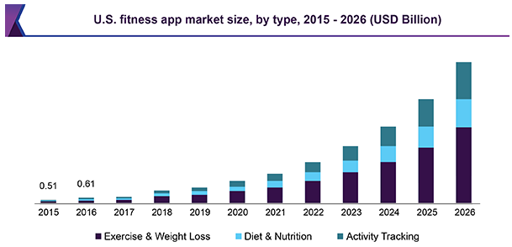

App User info :

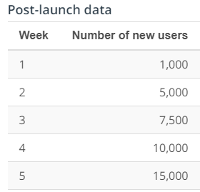

Competitors : health care application

-top 5 applications take 90% of market share

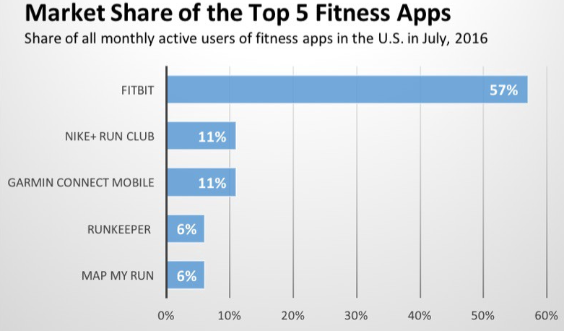

## Product Background:

Product positioning :

-for age 18 ~ 45 type 2 diabetes people, our healthy project app delivers great support to get motivate to transform from bad to healthy life. Because we build our app focusing on environment to get user to become physically active and have good diet plan. This approach has not been found from other apps.

Value proposition : main value of this app is motivation

-companion

-with app, user can have sense of bond

-remote support

-any questions are available

-clear & individualized process

-personalized activity given

-respect user’s goal

Features : Related to motivation

-reward system : external motivation tool to help patient to form good habit

-user can collect points by accomplishing mission. reward can be selected with points

-health test : deeper understand of own body

-help understand body in number and graphic

-internal motivation by facing seriousness of body condition

-24/7 Q&A : sense of bond and relation formed

-user can ask any questions

-help setting realistic goal

Issues : design & user friendly

-design : UI/UX has been iterating base on user feedback. design ticket will be done by next week.

-User friendly : we had found out from the review thatsome of the user have difficulty in using app. This issue is under consideration by engineer and design team.

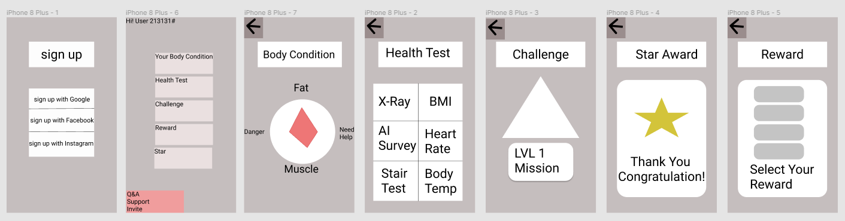

## Pricing:

Price : Freemium

-value : the app is focusing on KP’s patient to become healthy and reduce health care cost in the future

-cost : the cost for building app is relatively low compare to building preventive space

-price discrimination : user with high passion and motivation

Discount : benefit return to user who buzz

-people who invite other

-people post on blog or sns

Offerings : app user can get additional care by KP’s faculty

-stars are given to honorable user, with that star, speical reward are given